**แนวปฏิบัติในการสอบปากคำของพนักงานสอบสวน**

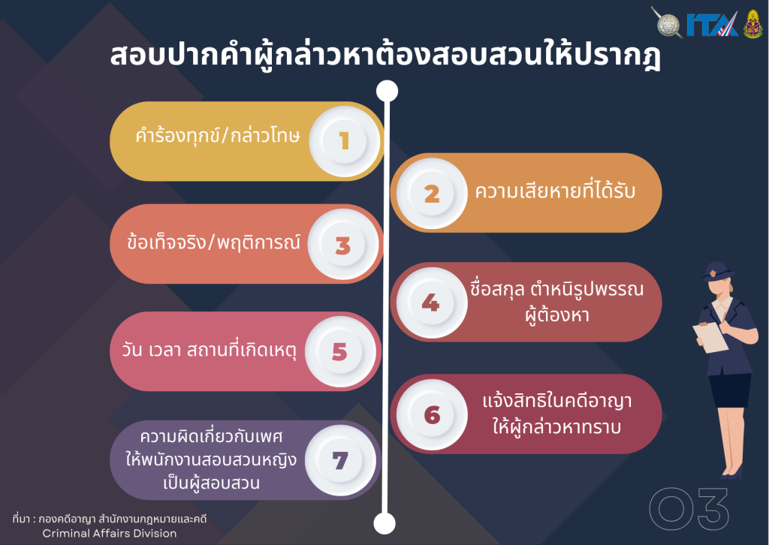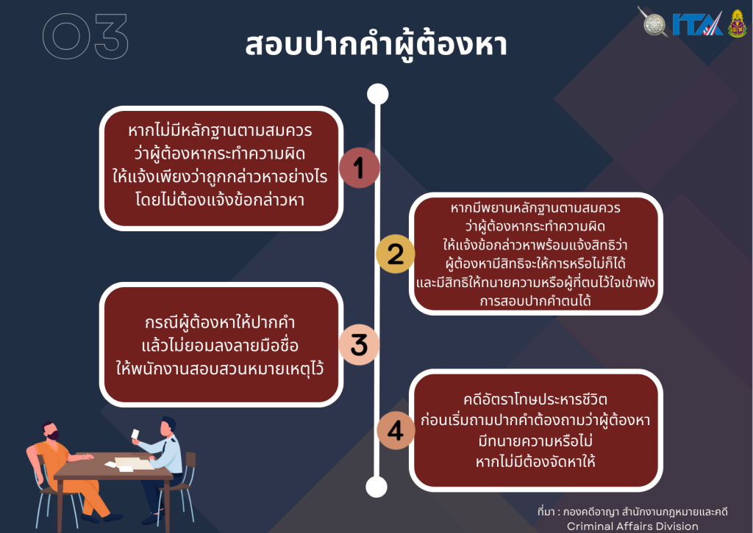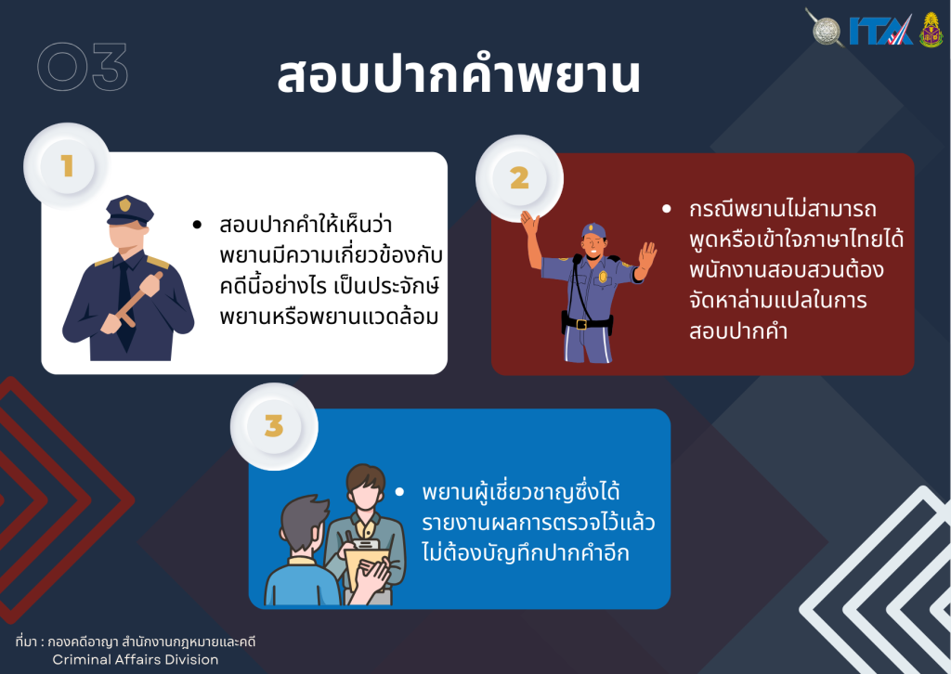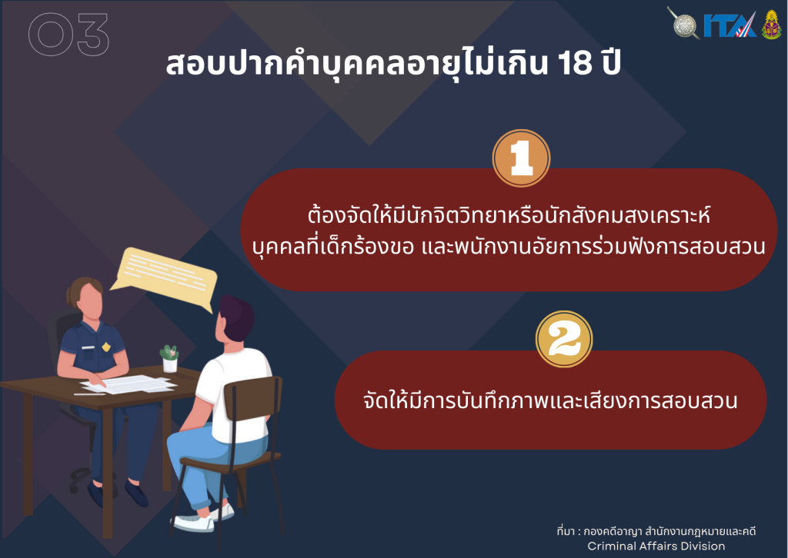

[แนวปฏิบัติในการสอบปากคำของพนักงานสอบสวน](https://mueangchiangmai.chiangmai.police.go.th/wp-content/uploads/2024/02/%E0%B9%81%E0%B8%99%E0%B8%A7%E0%B8%9B%E0%B8%8F%E0%B8%B4%E0%B8%9A%E0%B8%B1%E0%B8%95%E0%B8%B4%E0%B9%83%E0%B8%99%E0%B8%81%E0%B8%B2%E0%B8%A3%E0%B8%AA%E0%B8%AD%E0%B8%9A%E0%B8%9B%E0%B8%B2%E0%B8%81%E0%B8%84%E0%B8%B3%E0%B8%82%E0%B8%AD%E0%B8%87%E0%B8%9E%E0%B8%99%E0%B8%B1%E0%B8%81%E0%B8%87%E0%B8%B2%E0%B8%99%E0%B8%AA%E0%B8%AD%E0%B8%9A%E0%B8%AA%E0%B8%A7%E0%B8%99-1.pdf)