**แนวปฏิบัติในการใช้ดุลยพินิจไม่รับคำร้องทุกข์ในคดีอาญา**

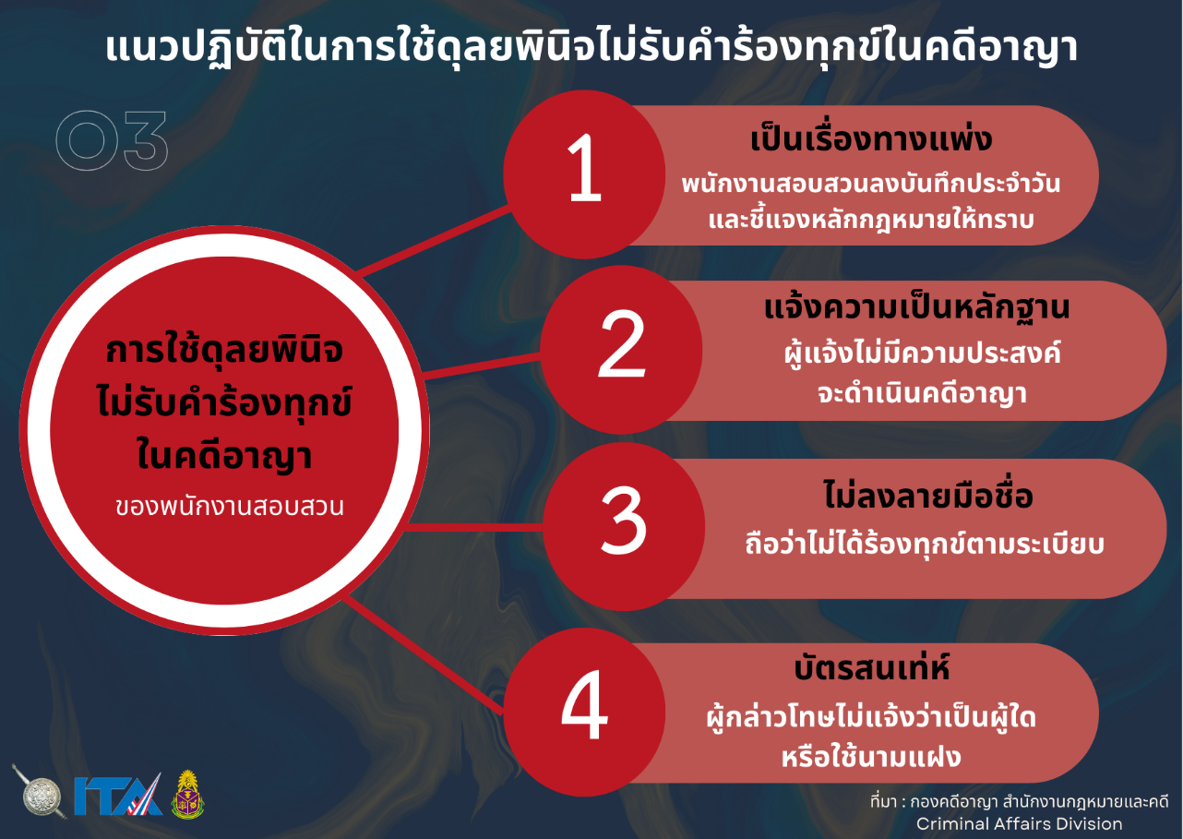

[แนวปฏิบัติในการใช้ดุลยพินิจไม่รับคำร้องทุกข์ในคดีอาญา-1](https://mueangchiangmai.chiangmai.police.go.th/wp-content/uploads/2024/02/368_O14-%E0%B9%81%E0%B8%99%E0%B8%A7%E0%B8%9B%E0%B8%8F%E0%B8%B4%E0%B8%9A%E0%B8%B1%E0%B8%95%E0%B8%B4%E0%B9%83%E0%B8%99%E0%B8%81%E0%B8%B2%E0%B8%A3%E0%B9%83%E0%B8%8A%E0%B9%89%E0%B8%94%E0%B8%B8%E0%B8%A5%E0%B8%A2%E0%B8%9E%E0%B8%B4%E0%B8%99%E0%B8%B4%E0%B8%88%E0%B9%84%E0%B8%A1%E0%B9%88%E0%B8%A3%E0%B8%B1%E0%B8%9A%E0%B8%84%E0%B8%B3%E0%B8%A3%E0%B9%89%E0%B8%AD%E0%B8%87%E0%B8%97%E0%B8%B8%E0%B8%81%E0%B8%82%E0%B9%8C%E0%B9%83%E0%B8%99%E0%B8%84%E0%B8%94%E0%B8%B5%E0%B8%AD%E0%B8%B2%E0%B8%8D%E0%B8%B2-1.pdf)